COMP3023 Design and Analysis of Algorithms
Spring 2023
Assignment 2

Given the following weighted simple undirected graph $G=(V,E)$, answer Question 1-3. If there are multiple choices, follow the alphabetical order. For example, the edge $(a,g)$ goes before the edge $(b,c)$ because $a<b$ in alphabet.
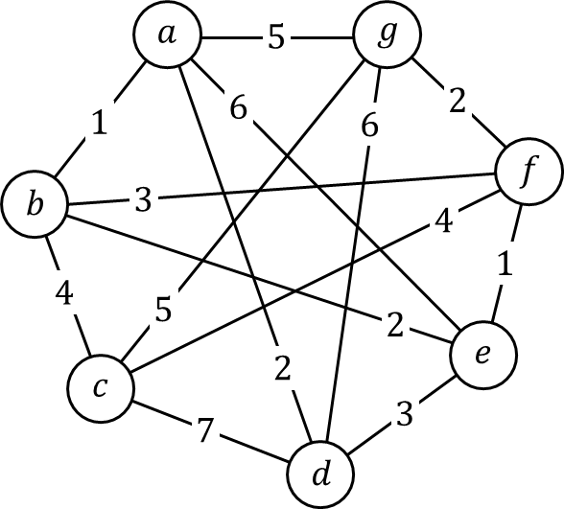
Question 1.
Show the execution of Prim’s algorithm to find the minimum spanning tree. In each step of the execution, you need to draw one graph to show the cut, the edges crossing the cut, and the light edge. You also need to build a table for each step to show $key[v]$, $pred[v]$ and the priority queue. Suppose the algorithm starts from vertex $d$.
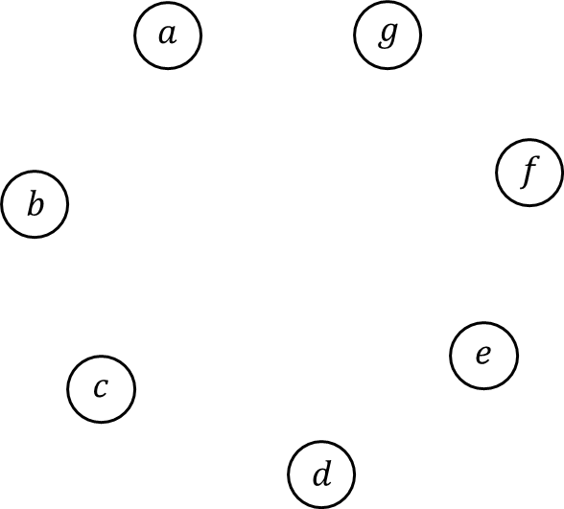
Initial:
vertices | $$a$$ | $$b$$ | $$c$$ | $$d$$ | $$e$$ | $$f$$ | $$g$$
$$key[v]$$ | $$∞$$ | $$∞$$ | $$∞$$ | $$0$$ | $$∞$$ | $$∞$$ | $$∞$$
$$pred[v]$$ | $$nil$$ | $$nil$$ | $$nil$$ | $$nil$$ | $$nil$$ | $$nil$$ | $$nil$$
Queue | $$d$$ | $$a$$ | $$b$$ | $$c$$ | $$e$$ | $$f$$ | $$g$$
 | $$0$$ | $$∞$$ | $$∞$$ | $$∞$$ | $$∞$$ | $$∞$$ | $$∞$$

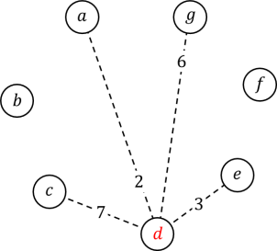
Step 1: select $d$
vertices | $$a$$ | $$b$$ | $$c$$ | $$d$$ | $$e$$ | $$f$$ | $$g$$
$$key[v]$$ | $$2$$ | $$∞$$ | $$7$$ | $$0$$ | $$3$$ | $$∞$$ | $$6$$
$$pred[v]$$ | $$d$$ | $$nil$$ | $$d$$ | $$nil$$ | $$d$$ | $$nil$$ | $$d$$
Queue | $$a$$ | $$e$$ | $$g$$ | $$c$$ | $$b$$ | $$f$$
 | $$2$$ | $$3$$ | $$6$$ | $$7$$ | $$∞$$ | $$∞$$

Step 2: select $a$
vertices | $$a$$ | $$b$$ | $$c$$ | $$d$$ | $$e$$ | $$f$$ | $$g$$
$$key[v]$$ | $$2$$ | $$1$$ | $$7$$ | $$0$$ | $$3$$ | $$∞$$ | $$5$$
$$pred[v]$$ | $$d$$ | $$a$$ | $$d$$ | $$nil$$ | $$d$$ | $$nil$$ | $$a$$
Queue | $$b$$ | $$e$$ | $$g$$ | $$c$$ | $$f$$
 | $$1$$ | $$3$$ | $$5$$ | $$7$$ | $$∞$$
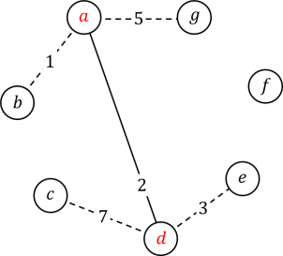
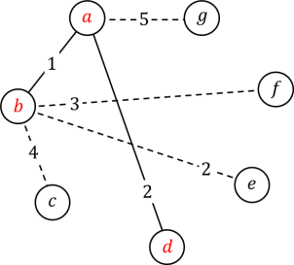
Step 3: select $b$
vertices | $$a$$ | $$b$$ | $$c$$ | $$d$$ | $$e$$ | $$f$$ | $$g$$
$$key[v]$$ | $$2$$ | $$1$$ | $$4$$ | $$0$$ | $$2$$ | $$3$$ | $$5$$
$$pred[v]$$ | $$d$$ | $$a$$ | $$b$$ | $$nil$$ | $$b$$ | $$b$$ | $$a$$
Queue | $$e$$ | $$f$$ | $$c$$ | $$g$$
 | $$2$$ | $$3$$ | $$4$$ | $$5$$

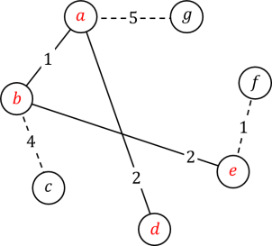
Step 4: select $e$
vertices | $$a$$ | $$b$$ | $$c$$ | $$d$$ | $$e$$ | $$f$$ | $$g$$
$$key[v]$$ | $$2$$ | $$1$$ | $$4$$ | $$0$$ | $$2$$ | $$1$$ | $$5$$
$$pred[v]$$ | $$d$$ | $$a$$ | $$b$$ | $$nil$$ | $$b$$ | $$e$$ | $$a$$
Queue | $$f$$ | $$c$$ | $$g$$
 | $$1$$ | $$4$$ | $$5$$

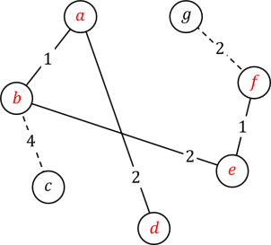
Step 5: select $f$
vertices | $$a$$ | $$b$$ | $$c$$ | $$d$$ | $$e$$ | $$f$$ | $$g$$
$$key[v]$$ | $$2$$ | $$1$$ | $$4$$ | $$0$$ | $$2$$ | $$1$$ | $$2$$
$$pred[v]$$ | $$d$$ | $$a$$ | $$b$$ | $$nil$$ | $$b$$ | $$e$$ | $$f$$
Queue | $$g$$ | $$c$$
 | $$2$$ | $$4$$

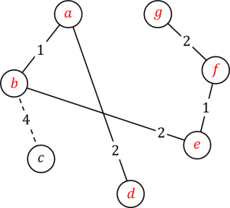
Step 6: select $g$
vertices | $$a$$ | $$b$$ | $$c$$ | $$d$$ | $$e$$ | $$f$$ | $$g$$
$$key[v]$$ | $$2$$ | $$1$$ | $$4$$ | $$0$$ | $$2$$ | $$1$$ | $$2$$
$$pred[v]$$ | $$d$$ | $$a$$ | $$b$$ | $$nil$$ | $$b$$ | $$e$$ | $$f$$
Queue | $$c$$
 | $$4$$

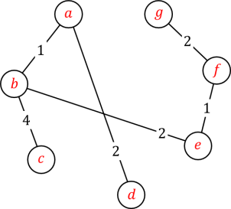
Step 7: select $c$
vertices | $$a$$ | $$b$$ | $$c$$ | $$d$$ | $$e$$ | $$f$$ | $$g$$
$$key[v]$$ | $$2$$ | $$1$$ | $$4$$ | $$0$$ | $$2$$ | $$1$$ | $$2$$
$$pred[v]$$ | $$d$$ | $$a$$ | $$b$$ | $$nil$$ | $$b$$ | $$e$$ | $$f$$
Queue

Done!
Question 2.
Show the execution of Kruskal’s algorithm to find the minimum spanning tree. In each step of the execution, you need to show the selected edge and the result of up tree (union find data structure) structure union by height. If there are multiple choices for the root, the alphabetically smaller vertex is the new root.
Sort edges by weights
$\left(a,b\right),\left(e,f\right),\left(a,d\right),\left(b,e\right),\left(g,f\right),\left(b,f\right),\left(d,e\right),\left(b,c\right),\left(c,f\right),\left(a,g\right),\left(c,g\right),\left(a,e\right),\left(d,g\right),(c,d)$
Initial:
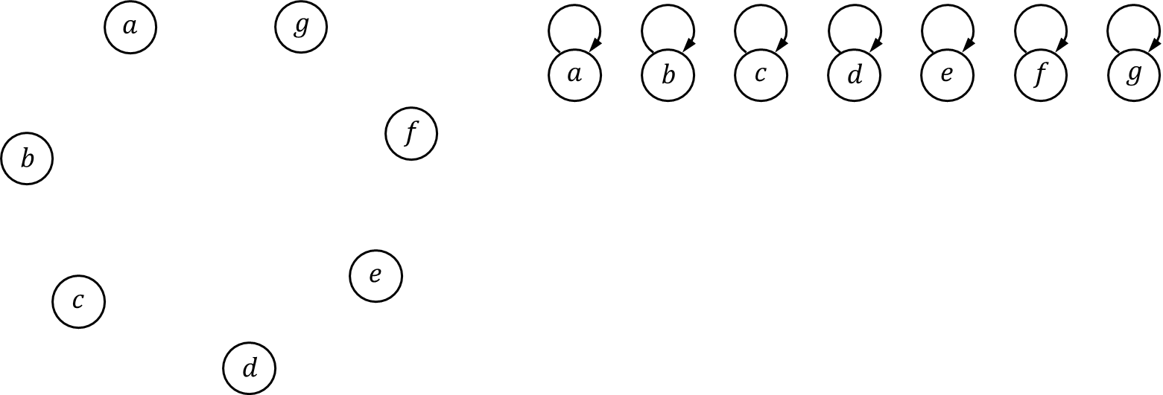
Step 1:
$\left(a,b\right),\left(e,f\right),\left(a,d\right),\left(b,e\right),\left(g,f\right),\left(b,f\right),\left(d,e\right),\left(b,c\right),\left(c,f\right),\left(a,g\right),\left(c,g\right),\left(a,e\right),\left(d,g\right),(c,d)$
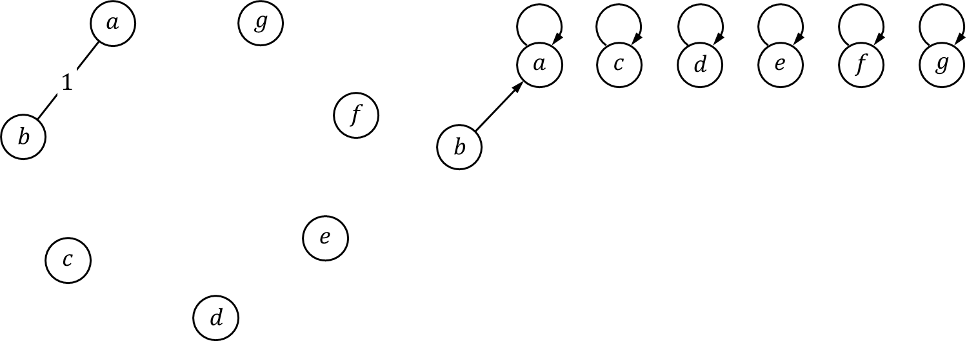
Step 2:
$\left(e,f\right),\left(a,d\right),\left(b,e\right),\left(g,f\right),\left(b,f\right),\left(d,e\right),\left(b,c\right),\left(c,f\right),\left(a,g\right),\left(c,g\right),\left(a,e\right),\left(d,g\right),(c,d)$
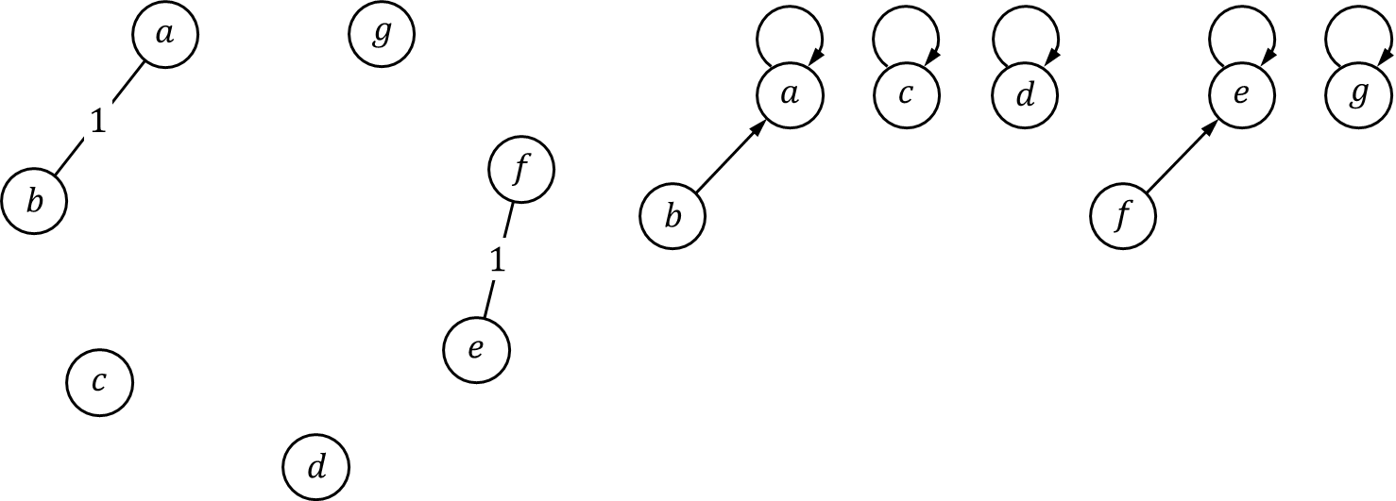
Step 3:
$\left(a,d\right),\left(b,e\right),\left(g,f\right),\left(b,f\right),\left(d,e\right),\left(b,c\right),\left(c,f\right),\left(a,g\right),\left(c,g\right),\left(a,e\right),\left(d,g\right),(c,d)$
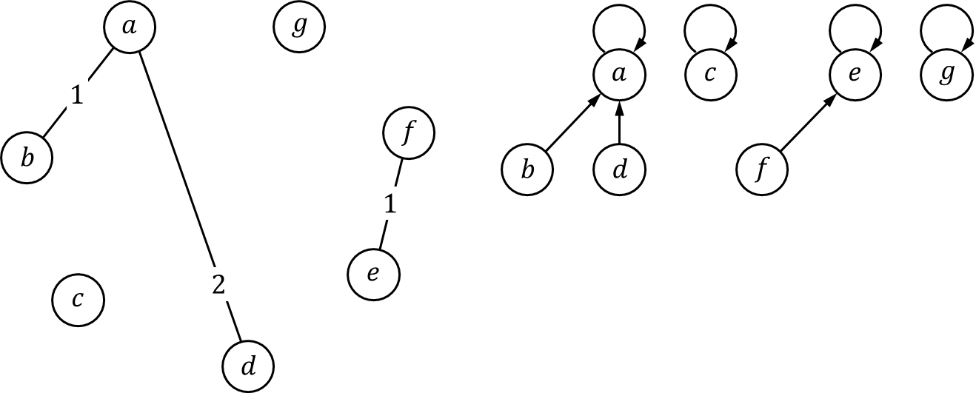

Step 4:
$\left(b,e\right),\left(g,f\right),\left(b,f\right),\left(d,e\right),\left(b,c\right),\left(c,f\right),\left(a,g\right),\left(c,g\right),\left(a,e\right),\left(d,g\right),(c,d)$
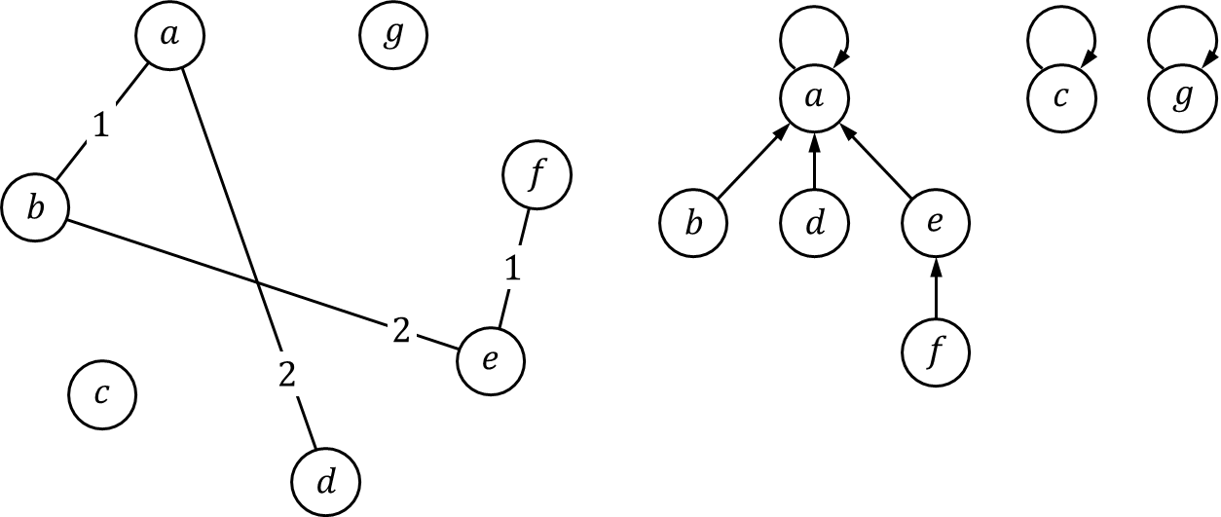
Step 5:
$\left(g,f\right),\left(b,f\right),\left(d,e\right),\left(b,c\right),\left(c,f\right),\left(a,g\right),\left(c,g\right),\left(a,e\right),\left(d,g\right),(c,d)$
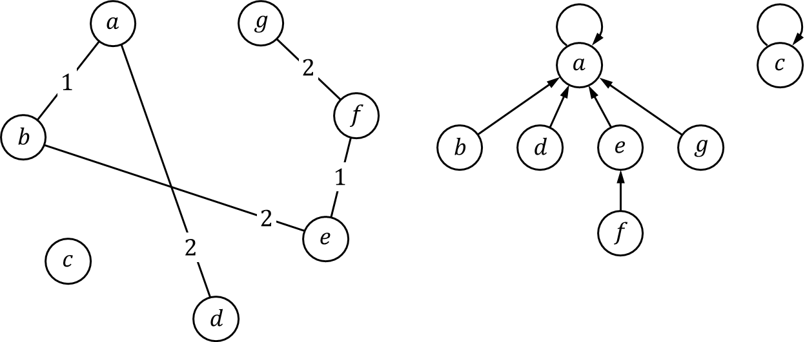
Step 6:
$\left(b,f\right),\left(d,e\right),\left(b,c\right),\left(c,f\right),\left(a,g\right),\left(c,g\right),\left(a,e\right),\left(d,g\right),(c,d)$
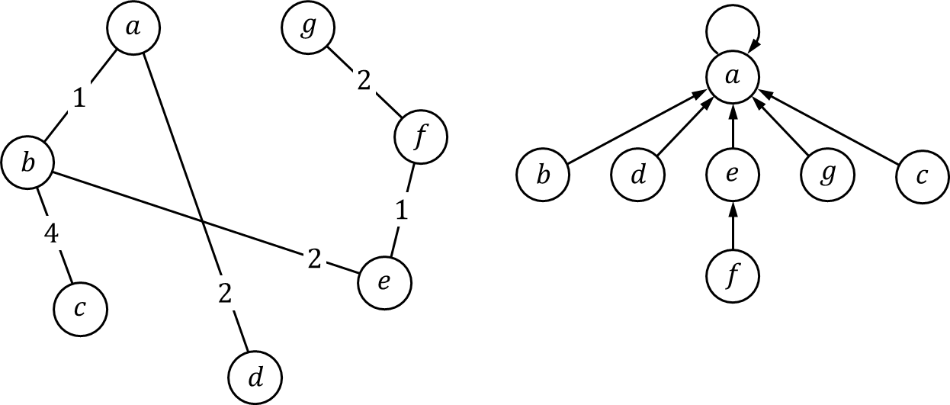
Done!
Question 3.
Show the execution of Dijkstra’s algorithm to find the shortest path from vertex $f$. You need to build a table to show the selected vertex, $d[v]$, $color[v]$ and $pred[v]$ for each step of the execution.
Initial:
vertices | $$a$$ | $$b$$ | $$c$$ | $$d$$ | $$e$$ | $$f$$ | $$g$$
$$d[v]$$ | $$∞$$ | $$∞$$ | $$∞$$ | $$∞$$ | $$∞$$ | $$0$$ | $$∞$$
$$color[v]$$ | $$W$$ | $$W$$ | $$W$$ | $$W$$ | $$W$$ | $$W$$ | $$W$$
$$pred[v]$$ | $$nil$$ | $$nil$$ | $$nil$$ | $$nil$$ | $$nil$$ | $$nil$$ | $$nil$$
Queue | $$f$$ | $$a$$ | $$b$$ | $$c$$ | $$d$$ | $$e$$ | $$g$$
 | $$0$$ | $$∞$$ | $$∞$$ | $$∞$$ | $$∞$$ | $$∞$$ | $$∞$$

Step 1: select $f$
vertices | $$a$$ | $$b$$ | $$c$$ | $$d$$ | $$e$$ | $$f$$ | $$g$$
$$d[v]$$ | $$∞$$ | $$3$$ | $$4$$ | $$∞$$ | $$1$$ | $$0$$ | $$2$$
$$color[v]$$ | $$W$$ | $$W$$ | $$W$$ | $$W$$ | $$W$$ | $$B$$ | $$W$$
$$pred[v]$$ | $$nil$$ | $$f$$ | $$f$$ | $$nil$$ | $$f$$ | $$nil$$ | $$f$$
Queue | $$e$$ | $$g$$ | $$b$$ | $$c$$ | $$a$$ | $$d$$
 | $$1$$ | $$2$$ | $$3$$ | $$4$$ | $$∞$$ | $$∞$$

Step 2: select $e$
vertices | $$a$$ | $$b$$ | $$c$$ | $$d$$ | $$e$$ | $$f$$ | $$g$$
$$d[v]$$ | $$7$$ | $$3$$ | $$4$$ | $$4$$ | $$1$$ | $$0$$ | $$2$$
$$color[v]$$ | $$W$$ | $$W$$ | $$W$$ | $$W$$ | $$B$$ | $$B$$ | $$W$$
$$pred[v]$$ | $$e$$ | $$f$$ | $$f$$ | $$e$$ | $$f$$ | $$nil$$ | $$f$$
Queue | $$g$$ | $$b$$ | $$c$$ | $$d$$ | $$a$$
 | $$2$$ | $$3$$ | $$4$$ | $$4$$ | $$7$$

Step 3: select $g$
vertices | $$a$$ | $$b$$ | $$c$$ | $$d$$ | $$e$$ | $$f$$ | $$g$$
$$d[v]$$ | $$7$$ | $$3$$ | $$4$$ | $$4$$ | $$1$$ | $$0$$ | $$2$$
$$color[v]$$ | $$W$$ | $$W$$ | $$W$$ | $$W$$ | $$B$$ | $$B$$ | $$B$$
$$pred[v]$$ | $$e$$ | $$f$$ | $$f$$ | $$e$$ | $$f$$ | $$nil$$ | $$f$$
Queue | $$b$$ | $$c$$ | $$d$$ | $$a$$
 | $$3$$ | $$4$$ | $$4$$ | $$7$$

Step 4: select $b$
vertices | $$a$$ | $$b$$ | $$c$$ | $$d$$ | $$e$$ | $$f$$ | $$g$$
$$d[v]$$ | $$4$$ | $$3$$ | $$4$$ | $$4$$ | $$1$$ | $$0$$ | $$2$$
$$color[v]$$ | $$W$$ | $$B$$ | $$W$$ | $$W$$ | $$B$$ | $$B$$ | $$B$$
$$pred[v]$$ | $$b$$ | $$f$$ | $$f$$ | $$e$$ | $$f$$ | $$nil$$ | $$f$$
Queue | $$a$$ | $$c$$ | $$d$$
 | $$4$$ | $$4$$ | $$4$$

Step 5: select $a$
vertices | $$a$$ | $$b$$ | $$c$$ | $$d$$ | $$e$$ | $$f$$ | $$g$$
$$d[v]$$ | $$4$$ | $$3$$ | $$4$$ | $$4$$ | $$1$$ | $$0$$ | $$2$$
$$color[v]$$ | $$B$$ | $$B$$ | $$W$$ | $$W$$ | $$B$$ | $$B$$ | $$B$$
$$pred[v]$$ | $$b$$ | $$f$$ | $$f$$ | $$e$$ | $$f$$ | $$nil$$ | $$f$$
Queue | $$c$$ | $$d$$
 | $$4$$ | $$4$$

Step 6: select $c$
vertices | $$a$$ | $$b$$ | $$c$$ | $$d$$ | $$e$$ | $$f$$ | $$g$$
$$d[v]$$ | $$4$$ | $$3$$ | $$4$$ | $$4$$ | $$1$$ | $$0$$ | $$2$$
$$color[v]$$ | $$B$$ | $$B$$ | $$B$$ | $$W$$ | $$B$$ | $$B$$ | $$B$$
$$pred[v]$$ | $$b$$ | $$f$$ | $$f$$ | $$e$$ | $$f$$ | $$nil$$ | $$f$$
Queue | $$d$$
 | $$4$$

Step 7: select $d$
vertices | $$a$$ | $$b$$ | $$c$$ | $$d$$ | $$e$$ | $$f$$ | $$g$$
$$d[v]$$ | $$4$$ | $$3$$ | $$4$$ | $$4$$ | $$1$$ | $$0$$ | $$2$$
$$color[v]$$ | $$B$$ | $$B$$ | $$B$$ | $$B$$ | $$B$$ | $$B$$ | $$B$$
$$pred[v]$$ | $$b$$ | $$f$$ | $$f$$ | $$e$$ | $$f$$ | $$nil$$ | $$f$$
Queue

Done! The shortest path tree is
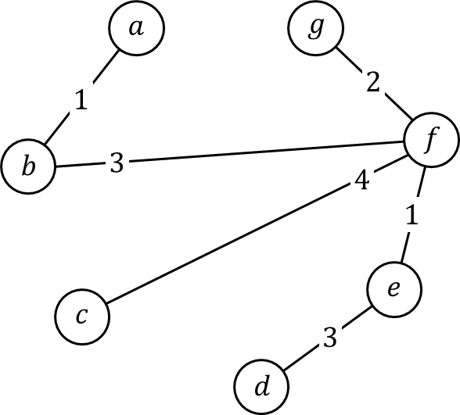

Question 4.
Is a minimum spanning tree a shortest path tree? Is a shortest path tree a minimum spanning tree? Prove your answer.
Ans.
No and No. Trivial

Question 5.
Given a list of $n$ tasks $T=(t_{1},t_{2},⋯,t_{n})$, a single task $t_{i}$ is accomplished by a cost $c_{i}$ and has two prerequisite lists of tasks $con[t_{i}]$ and $dis[t_{i}]$. Before doing task $t_{i}$, one must have finished all tasks in $con[t_{i}]$ and at least one task in $dis[t_{i}]$. We defined $cost(t_{i})$ be the total cost to finish $t_{i}$ and all tasks needed to be finished before $t_{i}$.
Sometimes $t_{i}$ is unsolvable if there is a deadlock. A deadlock happens if there is a sequence of tasks $t_{1}^{'},t_{2}^{'},⋯,t_{m}^{'}$ such that $t_{m}^{'}$ is the prerequisite of $t_{1}^{'}$ and $t_{i−1}^{'}$ is the prerequisite of $t_{i}^{'}$ (no matter $con[t_{i}^{'}]$ or $dis[t_{i}^{'}]$) for $1<i≤m$.
Design an algorithm to find the minimum cost to finish a given task. You need to formally model the problem using a graph. You need to precisely define the input and the output, describe your algorithm on a high level, present your algorithm by pseudo codes, and analyze the time complexity.
Ans.
The input can be modeled as a graph $G$ such that the vertex set is $T=\{t_{1},⋯,t_{n}\}$, the edge set is $E=C∪D$ where $C=\{(t_{i},t_{j})|t_{j}∈con[t_{i}]\}$ and $D=\{(t_{i},t_{j})|t_{j}∈dis[t_{i}]\}$. The cost $c_{i}$ becomes a weight on each vertex.
The intuition of the algorithm is using a modified version of DFS on the given task $t_{x}$. If the costs for all the prerequisite tasks of $t_{x}$ have been calculated, then the cost for $t_{x}$ is calculated.
To detect deadlocks, we use a flag $working[t_{i}]$ to show the current status of task $t_{i}$. If $working\left[t_{i}\right]=No$, the task $t_{i}$ is not being processed. If $working\left[t_{i}\right]=Yes$, the task $t_{i}$ is being processed but not finished. If $working\left[t_{i}\right]=Finished$, the task $t_{i}$ is finished and we know $cost(t_{i})$ already. Then, we observe that
Observation.
During the searching if there are tasks $t_{a}$ and $t_{b}$ such that $t_{b}$ is a prerequisite of $t_{a}$ and $working\left[t_{b}\right]=Yes$, then there is a deadlock.
proof.
Here, we present the intuition instead of a formal proof. Note that the flag $working[t_{b}]$ in fact is the $color[t_{b}]$ in the DFS. If the searching is calculating $cost(t_{a})$ while $working\left[t_{b}\right]=Yes$, it means that there is a prerequisite path from $t_{b}$ to $t_{a}$. However, $t_{b}$ is a prerequisite of $t_{a}$, which makes the path a cycle and implies a deadlock.
Or think about DFS, if two vertices $v$ and $u$ are both of color $gray$, then they are on the same branch of a subtree. One is the ancestor of the other. So, there is a path from $v$ to $u$ (or vice versa). If $v$ and $u$ are adjacent via another edge $(v,u)$, then there are two paths from $v$ to $u$, which forms a cycle.

Next, following the definition, $cost[t_{i}]$ is formally presented as
$cost\left[t_{i}\right]=\sum_{t_{c}∈con[t_{i}]}{cost[t_{c}]}+\min_{t_{d}∈dis[t_{i}]}{cost[t_{d}]}$ Equation 1
which implies the following algorithm (similar to DFS, we need a main routine for initialization).

Ans2.
In fact, Equation 1 is a recurrence relation. Together with the initial condition, it becomes
$$cost\left[t_{i}\right]=\left\{\begin{matrix}c_{i} & if con\left[t_{i}\right]=dis\left[t_{i}\right]=∅ \\ \sum_{t_{c}∈con[t_{i}]}{cost[t_{c}]}+\min_{t_{d}∈dis[t_{i}]}{cost[t_{d}]} & otherwise\end{matrix}\right.$$
And the above algorithm directly implements the recurrence relation using recursions. However, dynamic programming algorithms do differently. In the 3rd step of a dynamic programming algorithm, we do the bottom-up computation instead of a simple recursion. So, that will be interesting to practice this technique to convert the recursion function to loops and calculate $cost[t_{i}]$ from the initial condition.

